Lisimba

Functional Concept

# Terms and Concepts



## Gate

This is a Save/Load module for an address book. Usually, it is loaded from dll plugin files from the Gates directory.

## Gates List

This is the list of Gates available in the application;

It contains at least one gate: EmptyGate (a gate that does nothing). The rest of the gates are dynamically loaded at startup from the Gates directory.

## Default Gate

The Default Gate is chosen from the gates available in the Gates list, based on the configuration stored in the configuration file.

If there is any error in selecting the Default Gate, the EmptyGate is chosen instead.

The Default Gate is used in operations where a gate is needed but none is provided.

## Current Address Book

It is the address book containing the contacts displayed by the application.

At start up, the application decides, based on the configuration file, if an address book should be automatically opened or not.

The user can manually open an address book using the File->Open command or create a new one using the File->New command. The previously opened address book (if there is one) is automatically closed.

## Current Contact

It is a contact selected by the user from the Current Address Book. It is used in operations where a contact is needed but none is specified. It is also the contact displayed in the Contact Editor in the main window.

# Start Up

When the application starts, a few things happen:

* The Gates list is populated with the gates found in the Gates directory.
* The Default Gate is selected based on the value stored in the configuration file.
* An initial address book may be opened based on the information from the configuration file. The following options exists:
  + No address book is opened.
  + A new empty address book is created.
  + The last opened address book is opened. All the needed information (what is the last address book, what gate to use, what is its location) are taken from the configuration file.
  + A specific address book is opened. All the needed information (what gate to use, what is its location) are taken from the configuration file.

# Main Menu



* Displayed at the top of the window.

## „File” Menu

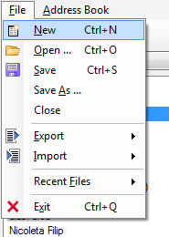

### „New” Menu Item

* Creates a new address book and sets it as Current Address Book.
* Displays the Address Book Panel.
* If another address book is already opened, it closes it. If the address book that is about to be closed is not saved, a popup should be displayed to ask the user if he wants to save it before closing. The user should have the option to save, to skip saving or to cancel the whole operation, in which case the new address book will not be created anymore.

### „Open” Menu Item

* Displays the Open File dialog to choose an .lsb file to be opened.
* If another address book is already opened, it will be closed. If the address book that is about to be closed is not saved, a popup should be displayed to ask the user if he wants to save it before continuing. The user should have the option to save, to skip saving or to cancel the whole operation, in which case the address book will not be opened anymore.

### „Save” Menu Item

* Enabled only if an address book is opened. When disabled, the text and the icon should be gray.
* Saves the address book in the location from where it was opened.
* If address book is new (it was never saved), shows the Save As dialog.

### „Save As” Menu Item

* Enabled only when an address book is opened. When disabled, the text and the icon should be gray.
* Displays the Save As dialog where the user can select a location for the address book to be saved.

### „Close” Menu Item

* Enabled only when an address book is opened. When disabled, the text and the icon should be gray.
* Closes the Current Address Book.
* The Address Book Panel is closed and the Start Panel is displayed.

### „Export” Menu Item

* Enabled only when an address book is opened. When disabled, the text and the icon should be gray.
* Opens a submenu containing the list of gates that can be used to export the Current Address Book.
* When a child menu item (gate) is clicked - Displays a save as window to save the Current Address Book using the specified gate. The gate and location are not associated with the address book.

### „Import” Menu Item

* Enabled only when an address book is opened. When disabled, the text and the icon should be gray.
* Opens a submenu containing the list of gates that can be used to import contacts into the Current Address Book.
* When a child menu item (gate) is clicked - Displays an open window to open address book from which the contacts will be imported into the Current Address Book. The gate and location of the Current Address Book are not changed.

### „Recent Files” Menu Item

* Opens a submenu containing the last 10 address books opened (location and gate).
* When a child menu item (address book) is clicked - the address book is opened using its associated gate.

### „Exit” Menu Item

* Closes the application.

## „Address Book” Menu

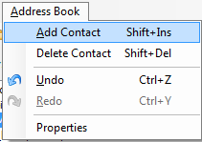

### „Add Contact” Menu Item

* Enabled only when an address book is opened. When disabled, the text and the icon should be gray.
* Displays the Add Contact Window.

### „Delete Contact” Menu Item

* Enabled only when a contact is selected. When disabled, the text and the icon should be gray.
* Removes the currently selected contact from its parent address book.
* A confirmation popup should be displayed before removing the contact.
* After the contact is deleted, the user should be able to undo the action using the Undo button.

### „Undo” Menu Item

* Enabled only when at least an action exists in the undo stack of the Current Address Book. When disabled, the text and the icon should be gray.
* Undoes the top action existing in the undo stack of the Current Address Book.
* Moves the top action from the undo stack into the redo stack.
* Any action performed on the Current Address Book is added in the undo stack.

### „Redo” Menu Item

* Enabled only when at least an action exists in the redo stack of the Current Address Book. When disabled, the text and the icon should be gray.
* Executes the top action existing in the redo stack and removes it from there.
* Adds the executed action into the undo stack.
* Any action performed on the Current Address Book is clearing the redo stack.

### „Properties” Menu Item

* Enabled only when an address book is opened. When disabled, the text and the icon should be gray.
* Displays the Address Book Properties Window.

## „Help” Menu



### „About” Menu Item

* Displays the About Window.

# Tool Bar



## „New” Tool Button

* When clicked, does exactly what File -> New Menu Item does.

## „Open” Tool Button

* When clicked, does exactly what File -> Open Menu Item does.

## „Save” Tool Button

* Enabled only when an address book is opened. When disabled, and the icon should be gray.
* When clicked, does exactly what File -> Save Menu Item does.

## „Undo” Tool Button

* Enabled only when an address book is opened. When disabled, and the icon should be gray.
* When clicked, does exactly what Address Book -> Undo Menu Item does.

## „Redo” Tool Button

* Enabled only when an address book is opened. When disabled, and the icon should be gray.
* When clicked, does exactly what Address Book -> Redo Menu Item does.

## „About” Tool Button

* When clicked, does exactly what Help -> About Menu Item does.

# Status Bar



## Status Text

* Displays the „Ready” text while idle.

## Gate Info

* Displays the name of the Default Gate.
* On click: displays the Change Gate Window.

# „Address Book” Panel

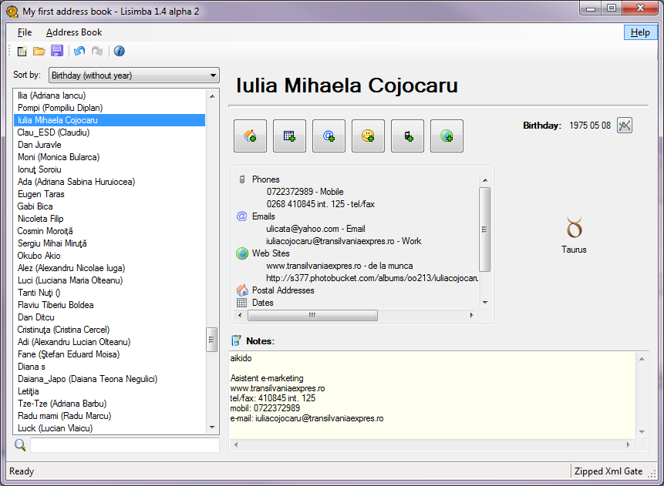

## „Sort by” Drop-down Box

* Possible values: Birthday (without year), Birth Date (age), First Name, Last Name, Nickname, Nickname or Name
* When an item is selected, orders the contacts displayed in the Contacts List as following:
  + Birthday - Orders the contacts by birthday ascending, ignoring the year, from January 1st to December 31st. The contacts that have no Birthday are displayed first, ordered by name.
  + Birth Date - Orders the contact by age ascending.
  + First Name - Orders the contact by first name ascending.
  + Last Name - Orders the contact by last name ascending.
  + Nickname - Orders the contact by nickname ascending.

## „Contacts” List

* Displays the list of contacts (the name of the contact) contained by the Current Address Book.
* Initially no contact is selected; Contact Editor Control is not displayed.
* When user selects a contact, the details of the contact are displayed in the Contact Editor Control
* If the user right clicks on a contact, a context menu is displayed.
* If the Current Address Book is closed, the list should be cleared.

## Contacts List - Context Menu

### „Add Contact” Menu Item

* Does exactly what Address Book -> Add Contact Menu Item does.

### „Delete Contact” Menu Item

* Does exactly what Address Book -> Delete Contact Menu Item does.

## Search Box

* Filters the displayed contacts in Contacts List. Only the contacts that contains the specified text are displayed.
* If nothing is written in the Search Box, all the contacts are displayed. Filter is not applied.

## „Contact Editor” Control

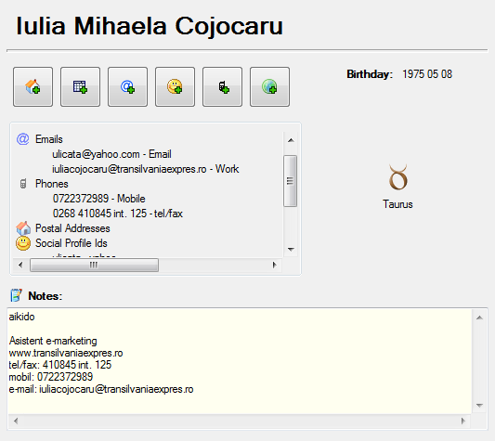

### „Name” Editor

* Displays the full name of the current contact as a label.
* If clicked it should be transformed in a text box where the user can edit the name.
* If Enter is pressed - save the changes
* If Esc is pressed - discard the changes.
* After the name is changed, the user should be able to undo the change using the „Undo” button.

### „Birthday” Label

* Displays the birthday of the contact in format „yyyy MM dd”.
* If contact does not have a birthday, „0000 00 00” should be displayed.
* If clicked, the Birthday Editor window should be displayed.

### „Birthday” Label - Alternate

* Displays the birthday of the contact in format „yyyy MM dd”.
* If contact does not have a birthday, „0000 00 00” should be displayed.
* If double clicked, a text box should be displayed instead of the label, letting the user to edit the value.
  + While the user types, the control should have a red border if the inserted value is not a correct date.
  + If ESC is pressed, the inserted value should be discarded.
  + If Enter is pressed or the control loses focus, the new value should be parsed and become the new birthday.

### „Zodiac Sign” Label

* Displays the name of the zodiac sign for the current contact.
* Displays an icon with the zodiac sign for the current contact.
* If the current contact does not have a zodiac sign, nothing should be displayed.

### „Contact Items” list

* TBD

### „Add Postal Address” button

* When clicked, display the Add Postal Address window.

### „Add Date” button

* When clicked, display the Add Date window.

### „Add Email Address” button

* When clicked, display the Add Email Address window.

### „Add Social Profile Id” button

* When clicked, display the Add Social Profile Id window.

### „Add Phone” button

* When clicked, display the Add Phone window.

### „Add Web Site” button

* When clicked, display the Add Web Site window.

### „Notes” Editor

* Displays the notes of the current contact.
* Can be edited by the user.
* After the text is changed, the user should be able to undo the change using the „Undo” button.

# „Start” Panel

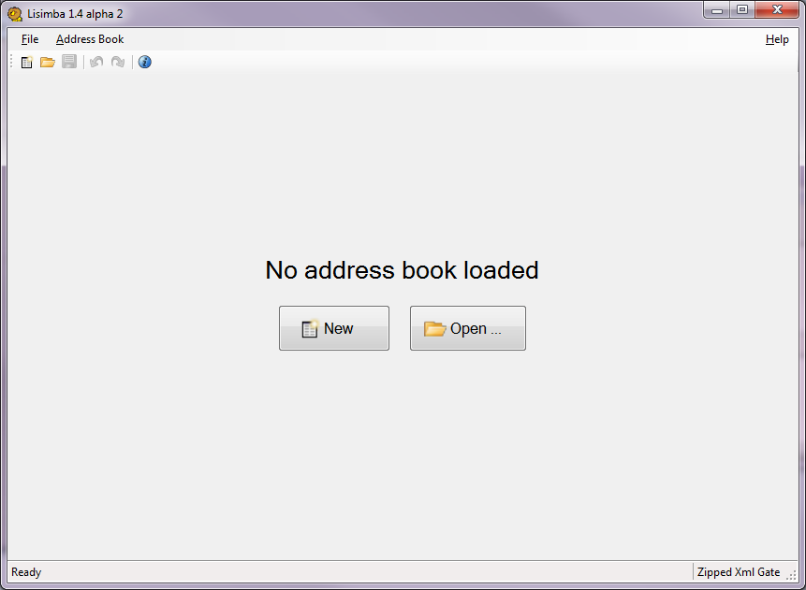

This panel is displayed if no Address Book is opened.

## „Info” Label

* Displays „No address book loaded” message

## „New” Button

* Does exactly what File -> New Menu Item does.

## „Open” Button

* Does exactly what File -> Open Menu Item does.

# „Change Gate” Window

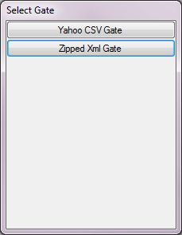

## List of buttons

* One button for each Gate that is loaded in the application.
* If a button is clicked, the corresponding Gate is set as Default Gate of the application.
* If window loses the focus, it closes.

# „Add Contact” Window

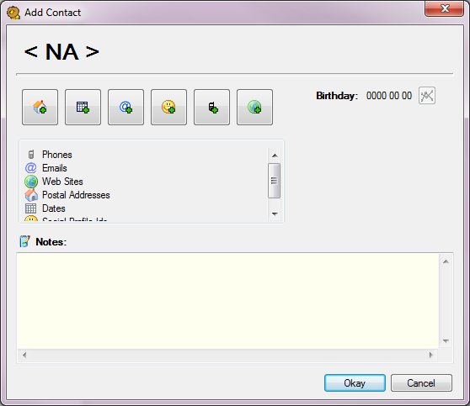

## „Contact Editor” Control

* Identical to the one in Address Book Panel with the only difference that it edits a new empty contact, not added yet to any address book.

## „Okay” Button

* Adds the edited contact to the Current Address Book and closes the window.

## „Cancel” Button

* Closes the window. The edited contact is discarded.

# „Properties” Window

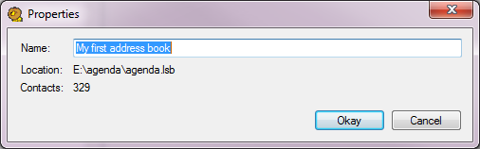

## „Name” Text Box

* Displays the name of the address book.
* It is editable.

## „Location” Label

* Displays the location from where the address book was loaded.
* If the address book is new, a message between angular brackets is displayed. (ex: „< Address book is not saved yet >”
* Read-only
* The text is selectable and can be copied to clipboard.

## „Contacts” Label

* Displays the number of contacts contained by the address book.
* Read-only
* The text is selectable and can be copied to clipboard.

## „Okay” Button

* Updates the name of the address book with the new value (if it was changed by the user) and closes the window.

## „Cancel” Button

* Closes the window without making any changes to the address book.

# „About” Window

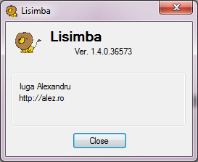

## Header

Contains:

* the icon of the application
* the name of the application
* the version of the application (all 4 components of the version)

## Body

Contains:

* the author
* the web page of the application

## „Close” Button

* When clicked - closes the window.

# Actions that can be undone

* Change the name of the address book
* Add a new contact
* Delete a contact
* Change the name of a contact
* Change the birthday of a contact
* Add an item in to a contact
* Delete an item from a contact
* Change an item from a contact
* Change the notes of a contact